Logo:
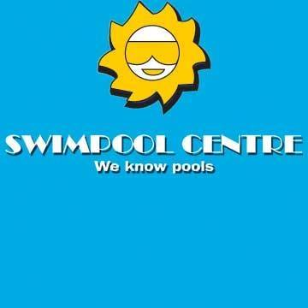
Location in PE:
43 Third Avenue, Newton Park, Port Elizabeth, South Africa
Phone number:
041 365 1257
Email:
swimpool@intekom.co.za
Site:
https://www.swimpoolcentre.com/

